**Release notes for iSnFRBase0711**

**“Locking” vs “check-in / check-out”**

Locking a worksheet prevents users to move, change or delete data in a worksheet. Specific cells or entire worksheets can be locked/protected.

Check-in and check-out prevent conflicts where multiple users need to edit the same files. When a file is checked-out to a user, only that user can work on the file. Other users cannot see the new changes while a file is checked-out. When a new or modified file is checked-in, it is added to a document library and can be viewed by other users.

**Sensors_OpuBC_cpXFP**

* The sensor numbers (Sxxx) in this worksheet are a **Primary Key.** They must be unique: appearing in only a single row.
* Users should enter data into **only** the columns with stippled headers.
* Be sure a new construct has a Sensor_Number.
* You may change the 3-digit number in a “changeable” header to YFC (your favorite codon). If you keep the 3-digital format, YFC updates automatically.
* The “Construct vs Ligands” section updates automatically, as a quick way to show the number of ligands studied for each sensor.
* To edit data:
  + Users can edit data into all columns after unlocking the worksheet. Follow the instructions in the Unprotect/Protect a worksheet section.
* Lock the worksheet after you finish.
* Check-in the file after you finish.

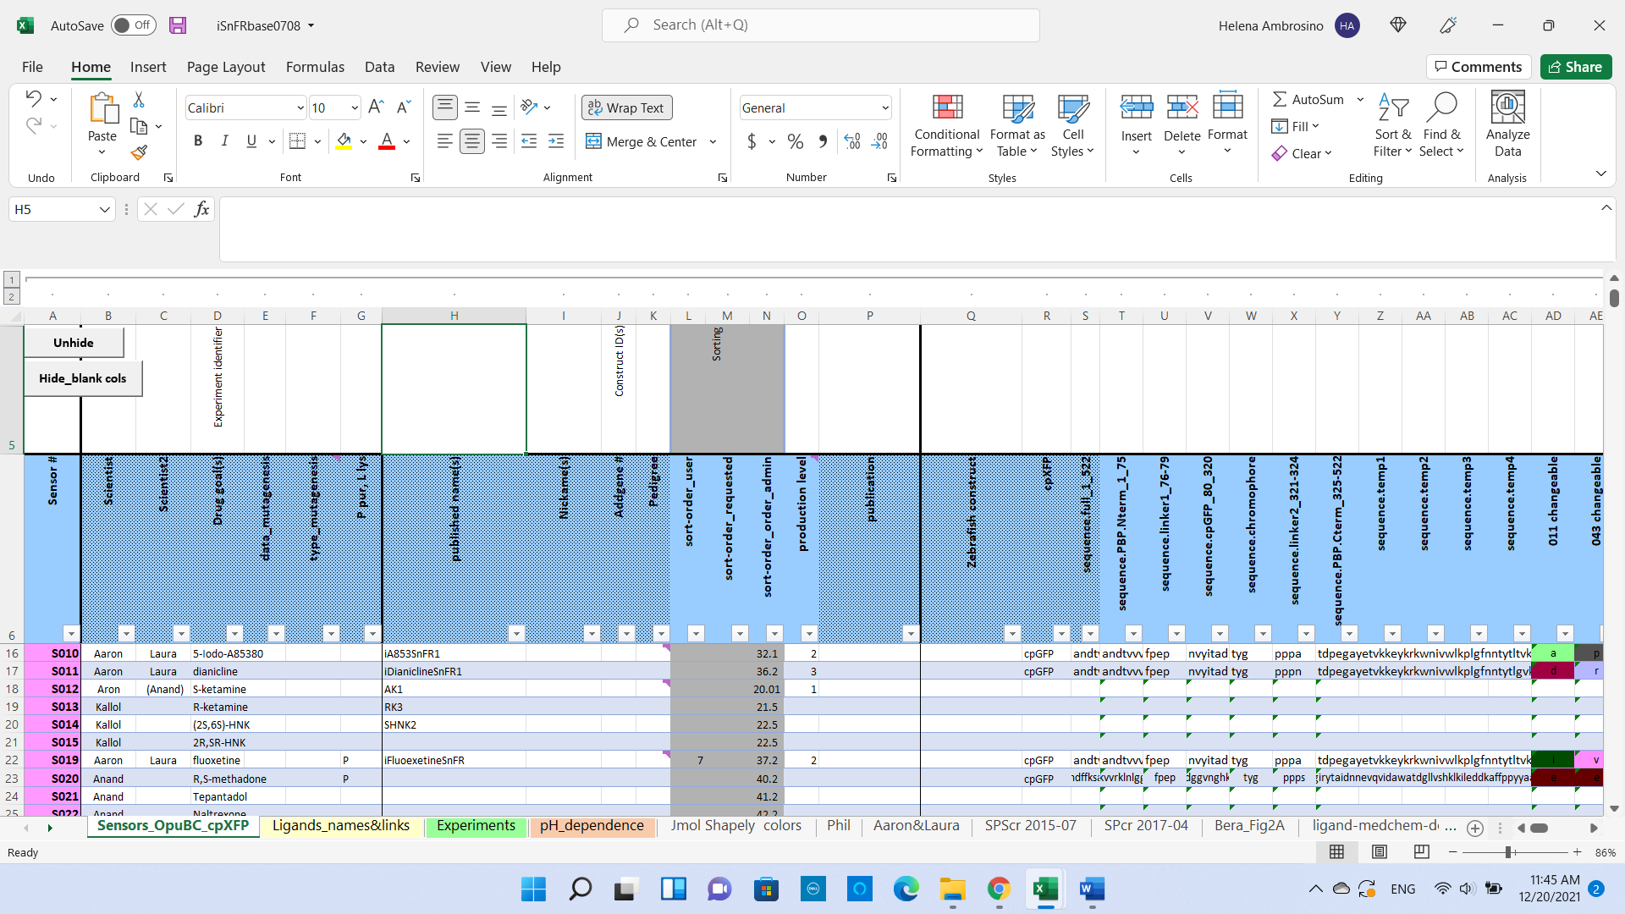

**Ligands_names_and_links**

* The ligand numbers (Lxxx) in this worksheet are a **Primary Key.** They must be unique: appearing in only a single row.
* Users can enter data into all columns after unlocking the worksheet. Follow the instructions in the Unprotect/Protect a worksheet section.
* If new ligands need to be added, rename ligands from “c” to “p”; they already have Ligand_Numbers.
* Lock the worksheet after you finish.
* Check-in the file after you finish.

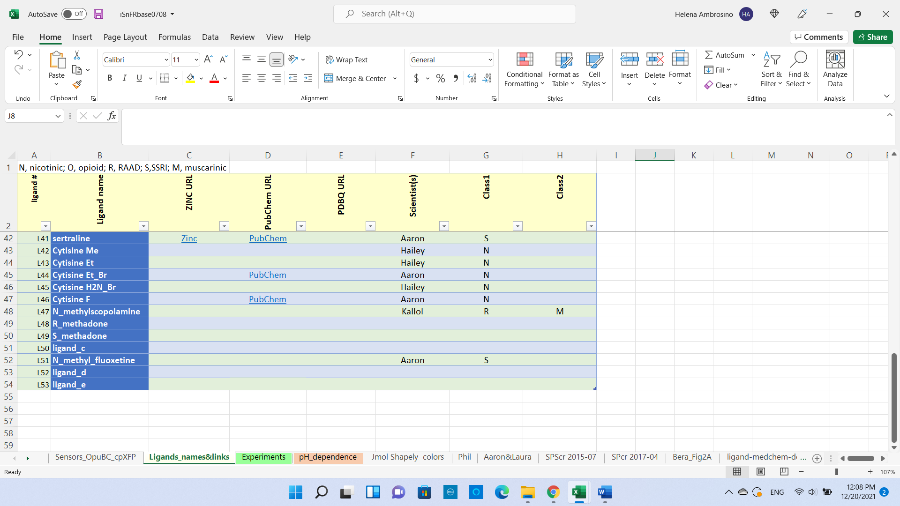

**Experiments**

* This worksheet has two “foreign keys”. Sensor_Number and Ligand_Number.
* Several rows can—and do—have the same Sensor_Number.
* Several rows can—and do—have the same Ligand_Number.
* There ought to be a routine that allows only a single (Ligand_Number)(Sensor_Number) pair—but this does not yet exist.
* Users should enter data **only** into the columns with stippled headers after unlocking the worksheet.
* Non-stippled headers denote columns that populate automatically.
* To edit experimental data:
  + Users can edit data into all columns after unlocking the worksheet. Follow the instructions in the Unprotect/Protect a worksheet section.
* Lock the worksheet after you finish.
* Check-in the file after you finish.

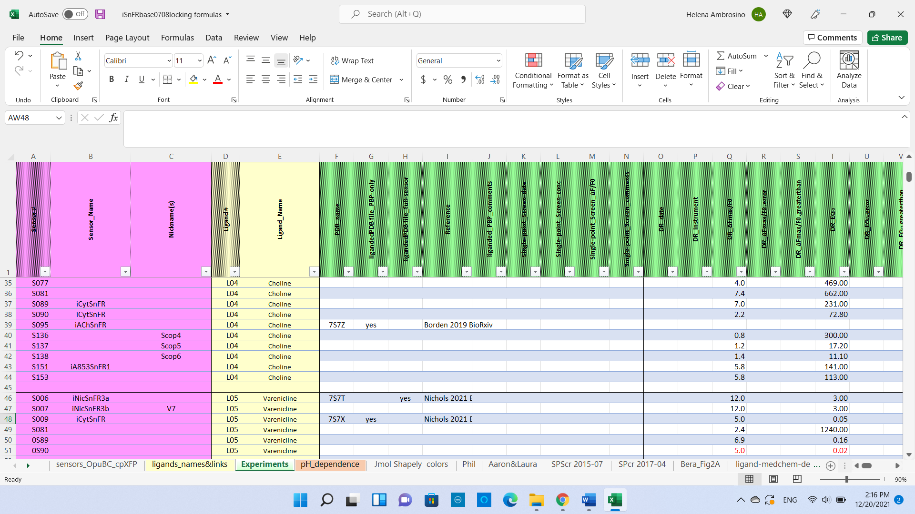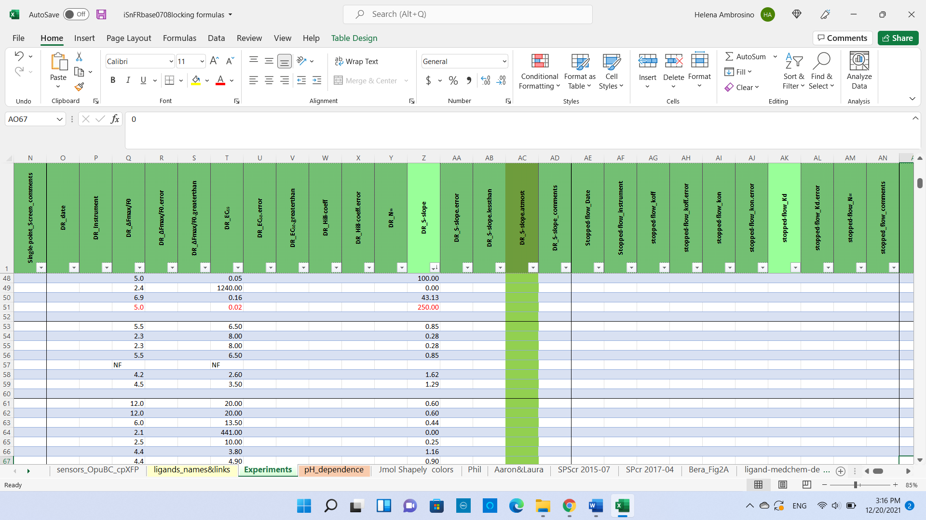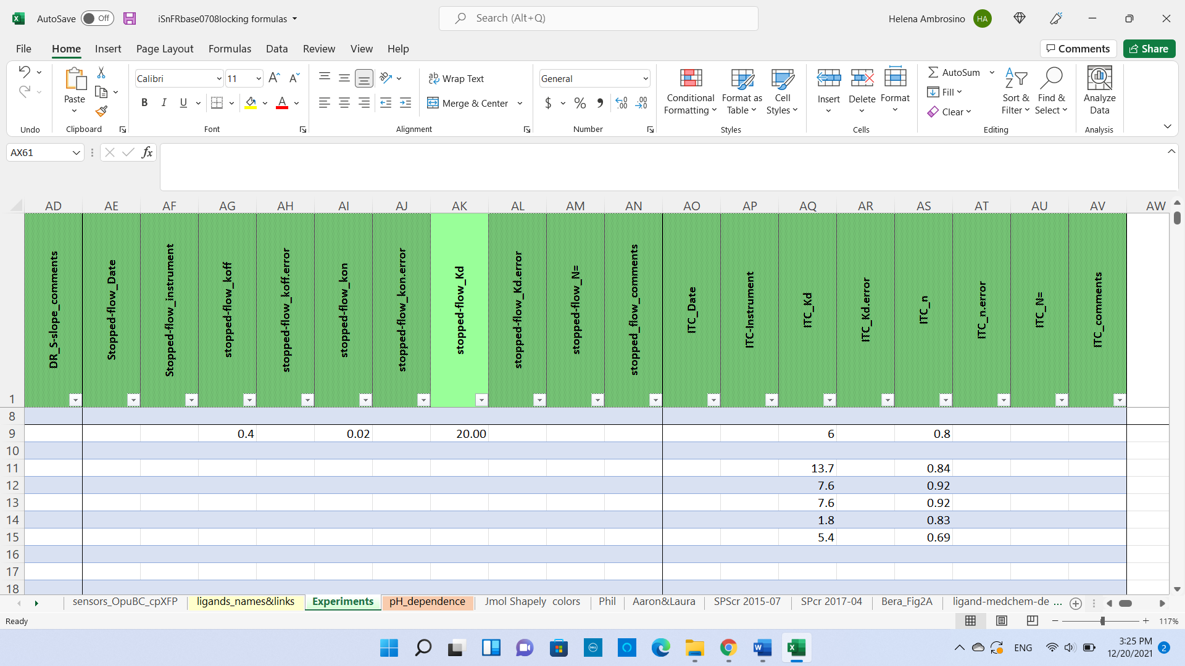

* To add new experimental data:
  + Both **Sensor_Number** and **Ligand_Number** must be present.
  + Check whether a row already has the **Sensor_Number** - **Ligand_Number** pair.
  + If yes, enter the new data for that pair.
  + If no, insert a row with the pair.
  + Remember that the unliganded sensor has the APO ligand, L02.
  + Enter the applicable data: structure, D/R analysis, stopped flow analysis and ITC.
  + Check-in the file after you finish.
* The following paragraphs treat apparently nonresponsive construct x ligand pairs. Reporting that an extremely small response exists has value for defining binding sites, and we should include this fact in our analyses. The same is true for responses that don’t saturate, therefore don’t allow an EC50, and therefore don’t allow an S-slope calculation from deltaFMax/EC50.
* Treat such cases as follows. It is **always** possible to find an approximate S-slope from the start of the dose-response relation. Make a graph on linear concentration co-ordinates. For constructs that don’t respond at the lower concentrations, find the first response, at concentration C. The approximate S-slope is (deltaFMax/F0 at C )/C. For cases where you measure good responses that don’t begin to level off, you have a better estimate of the S-slope.
* In either case, you now have a number to enter in “DR_S-slope column”. But it’s uncertain, so enter the same number in “DR_S-slope.error”.
* You’ve accomplished our goals . . . you have entered a number, but a small one; and you have stated the possibility that the S-slope could be zero. This tactic is preferable to having a column, “DR_S-slope.lessthan”.
* If it is a new ligand:
  + - Follow instructions described in Ligands_names_and_links

**pH_dependence**

If you have used “Experiments”, this worksheet needs no explanation.

**Other worksheets in iSnFRbase.**

These are archives, references, etc. They are not part of the relational database.

**Protect/Unprotect a worksheet**

* Require only if the user needs to add columns or modify formulas.
* Password: iSnFRBase
* Unprotect a worksheet:
  + Go to “Review” “Unprotect Sheet”
    - Type password

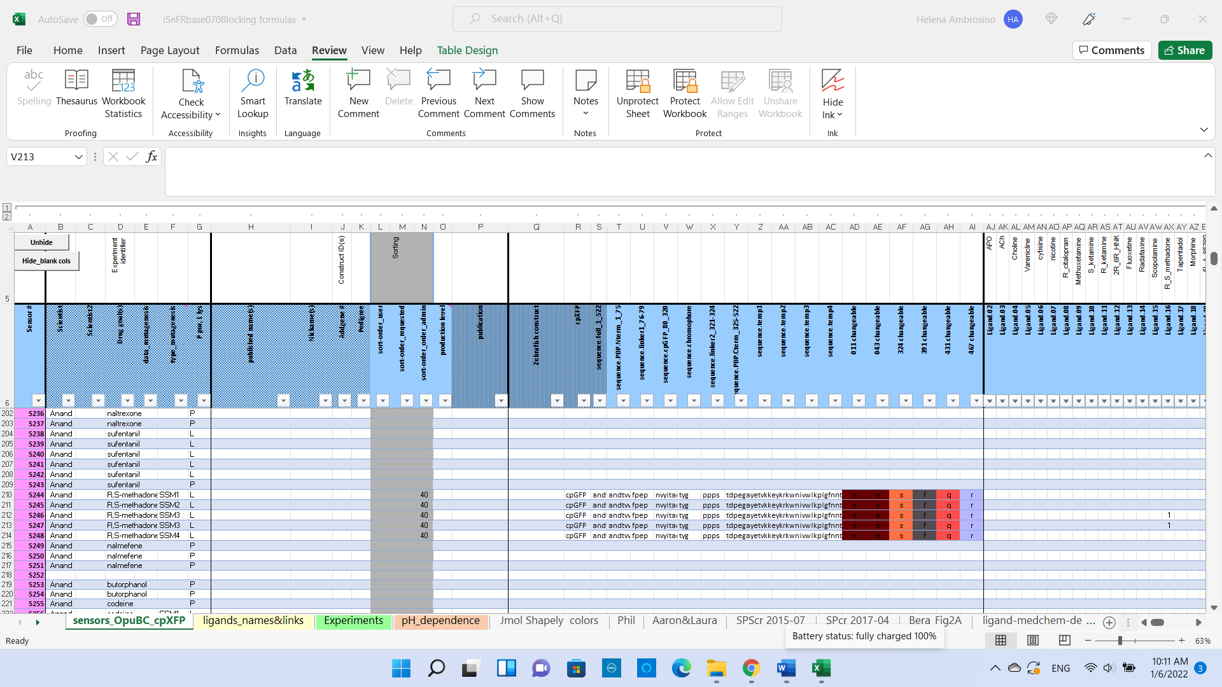

* Protect a worksheet:
  + Go to “Review” “Protect Sheet”
    - **Do not change any conditions for users**
    - Type password

**Changes in this version**

14 June 2022

TheExcel file newly named “iSnFRBase0710” used to be named “iSnFRBase0709”.

That’s because we’ve changed the file extension from xlsm to xlsx.

20 June 2022

TheExcel file newly named “iSnFRBase0711” used to be named “iSnFRBase0710”.

That’s because we’ve deleted the buttons “unhide” and “hide blank cols” on the Sensors_OpuBC_cpXFP worksheet.